**SET UP TACACS & RADIUS SERVERS**

Juntao Zhong

ccnp (cisco certified network professional)

NOV. 2018

NEWPORT HIGH SCHOOL, WA

## Purpose

The purpose of this lab is to implement TACACS+ (Terminal Access Controller Access Control Service Plus) and RADIUS (Remote Access Dial-In User Service), in order to manage all my network devices under a single platform.

## Backgroud:

TACACS+ and RADIUS are both AAA (Authentication, Authorization and Accounting) protocols that centralizes network device management into one server. In a cooperation with many network devices, altering network policies in each device can be overwhelming and error-prone. Thus, including all devices into a single platform would be more efficient and have less security issues or service interruption.

Both TACACS+ and RADIUS work based on the concept of central authorization. In tradition of local authorization (such as console password, telnet or ssh passwords), an administrator enters the password for each device, the device either allow or deny his/her access, and administrator configures that device. On another hand, in a centralized platform, network devices trust a TACACS+ or RADIUS server (server is already authenticated during the initial configurations), and an administrator can log in to every device under the server with one set of username and key. Here is an analogy: before, the admin needs 30 keys for all 30 houses. Now, all houses are in a secured wall, guarded by a server; the admin now can access all houses as soon as he/she passes the guard. One centralized “guard” server is more secure than separated passwords in devices, because network admin can closely monitor and implement better security into one server.

TACACS+ is relatively new and superior compared to RADIUS. RADIUS determines users’ privilege based on privilege level 1-15, but privilege levels mean different things for different vendors. RADIUS will also conflict if two administrators configure the device at the same time. So, TACACS+ is a newer version of AAA protocols and better than RADIUS.

## Lab summary

I configured TACACS+ on Linux Ubuntu 14.04.5 LTS, and RADIUS server on Windows Server 2016. I use VMware to load the ISO images of those two systems and configure AAA in two separated physical routers.

To summarize the setup for Linux server, I installed TACACS+ through CLI (Command-line Interface). I found the folder for TACACS+ configuration, entered groups, users and their privilege levels, as well as the authentication with network devices. And the server is good to go.

It was a little more complicated with Windows GUI, with a lot of clicking. First, I downloaded and configured Active Directory Domain Service (AD DS) and configured the users and groups there. Then, I added Network Policy Server into service and created a domain for all network devices under my RADIUS AAA system. Lastly, I configured the authentication with network devices.

## Lab Diagram

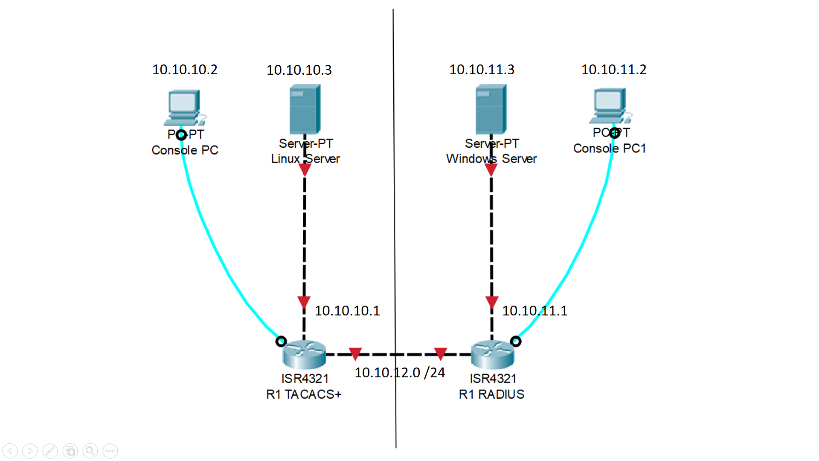

## Lab commands

Sudo -i

AAA authentication

Backup

Ish

## configuration of both servers and routers

### Linux Router configuration:

**Router(config)#** **hostname R1**

aaa new-model

aaa authentication login default group tacacs+ local

aaa authentication enable default group tacacs+ enable

aaa authorization config-commands

aaa authorization commands 0 default group tacacs+ none

aaa authorization commands 15 default group tacacs+ none

aaa accounting send stop-record authentication failure

aaa accounting update newinfo periodic 5

aaa accounting exec default start-stop group tacacs+

aaa accounting network default start-stop group tacacs+

aaa session-id common

ip domain name cisco.com

vtp domain cisco

username backup password 0 cisco

interface GigabitEthernet0/0

ip address 10.10.10.1 255.255.255.0

no shutdown

ip tacacs source-interface GigabitEthernet0/0

tacacs-server host 10.10.10.3

tacacs-server directed-request

tacacs-server key 123456

### Linux Server Setup:

First, I entered “**sudo -i**” in command prompt to get to Linux root, and issued “**apt-get update**” so that my Linux can download other things from the internet.

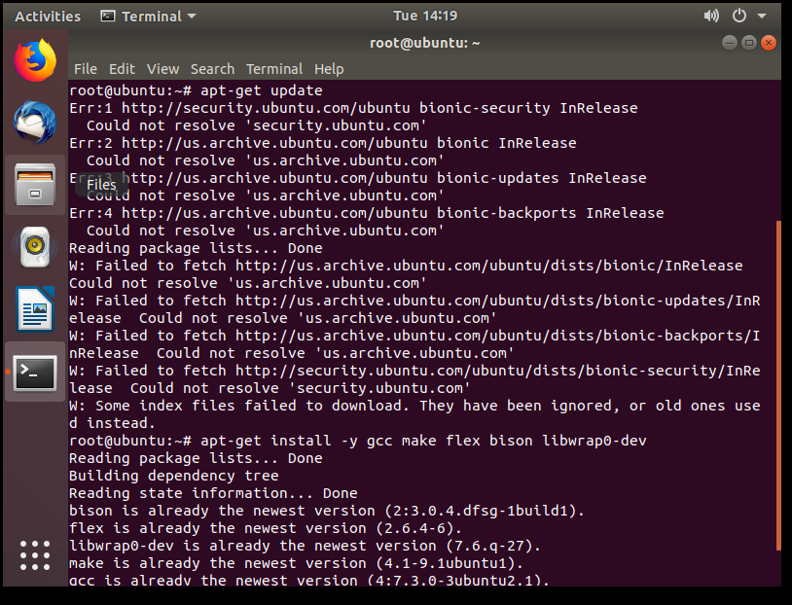

Then, I entered “**apt-get install -y gcc make flex bison libwrap0-dev**” and “**apt-get install tacacs+**” to install TACACS+ service in my Linux.

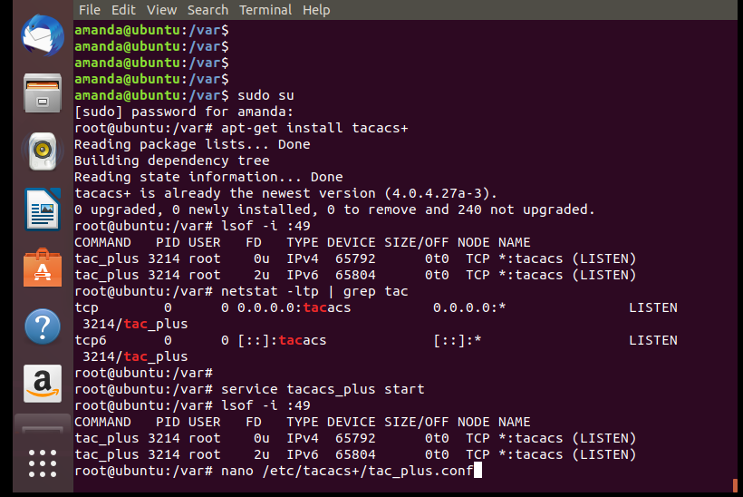

After downloading TACACS+ service, I edited its configuration file section with “**nano …**”to setup TACACS+.



Inside the configuration file, I defined the key (domain) between my server and router, the group with privilege levels and users in such groups.

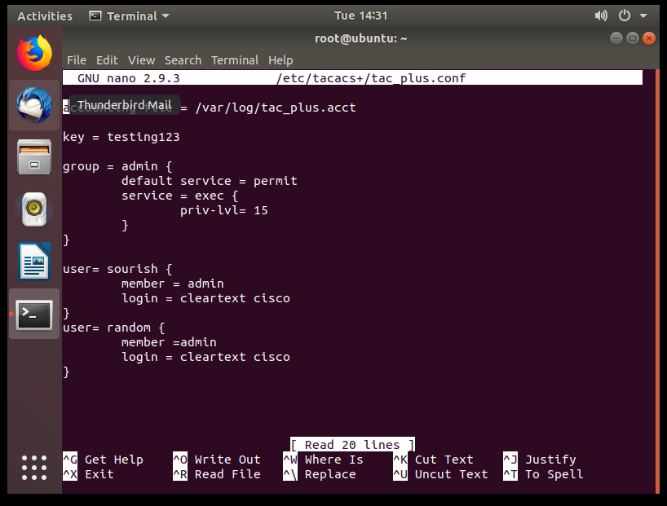

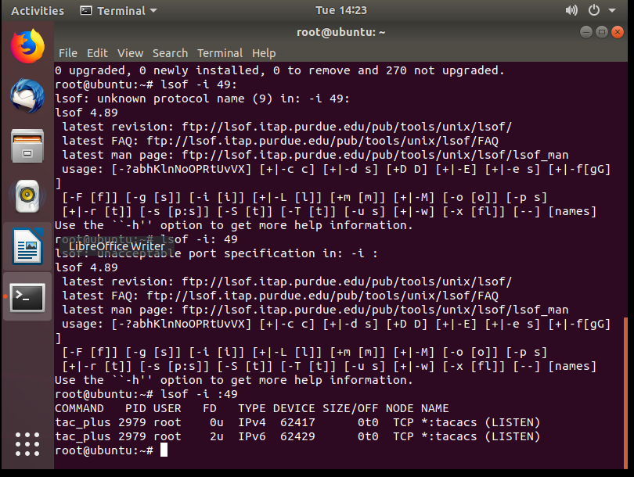

The last step was to check port 49 with “**lsof -i :49**” to see whether TACACS+ was running. The spelling and space must be exact for it to work. Then, TACACS+ platform was good to go.

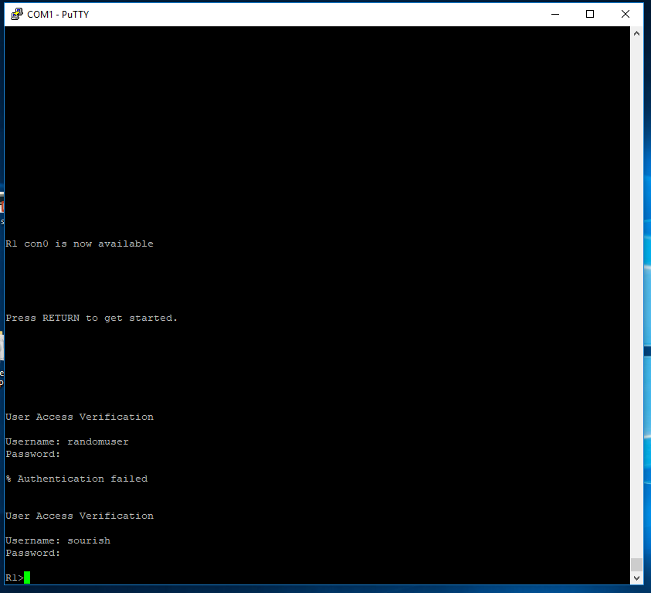

That’s what I saw when I console into my router. If ssh or telnet was configured, the User Access Verification should be similar as well.

### Windows Router Commands:

**Router(config)#** **hostname R1**

### enable password cisco

### aaa new-model

### aaa authentication login default group radius local

### aaa authorization exec default group radius if-authenticated

### Username backup password cisco

### aaa session-id common

### vtp domain cisco

### interface GigabitEthernet0/0

### ip address 10.10.10.1 255.255.255.0

### no shutdown

### radius-server host 10.10.10.3 key 123456

### line con 0

### password 123456

### Windows Server Setup:

Since Windows has a nice-looking graphic user interface, there are a lot of clicking and screens involved. There are three main components for RADIUS: Active Directory Domain Service (AD DS), Network Policy Server (NPS) and the authentication with routers.

#### **Preparation Step: download the services needed.**

First, I enter the **Dashboard** for Server. Hover over the **Manage** tab and click on “**Add Roles and Features**”. We are going to download AD DS and NPS. Make sure the server connects to Internet.

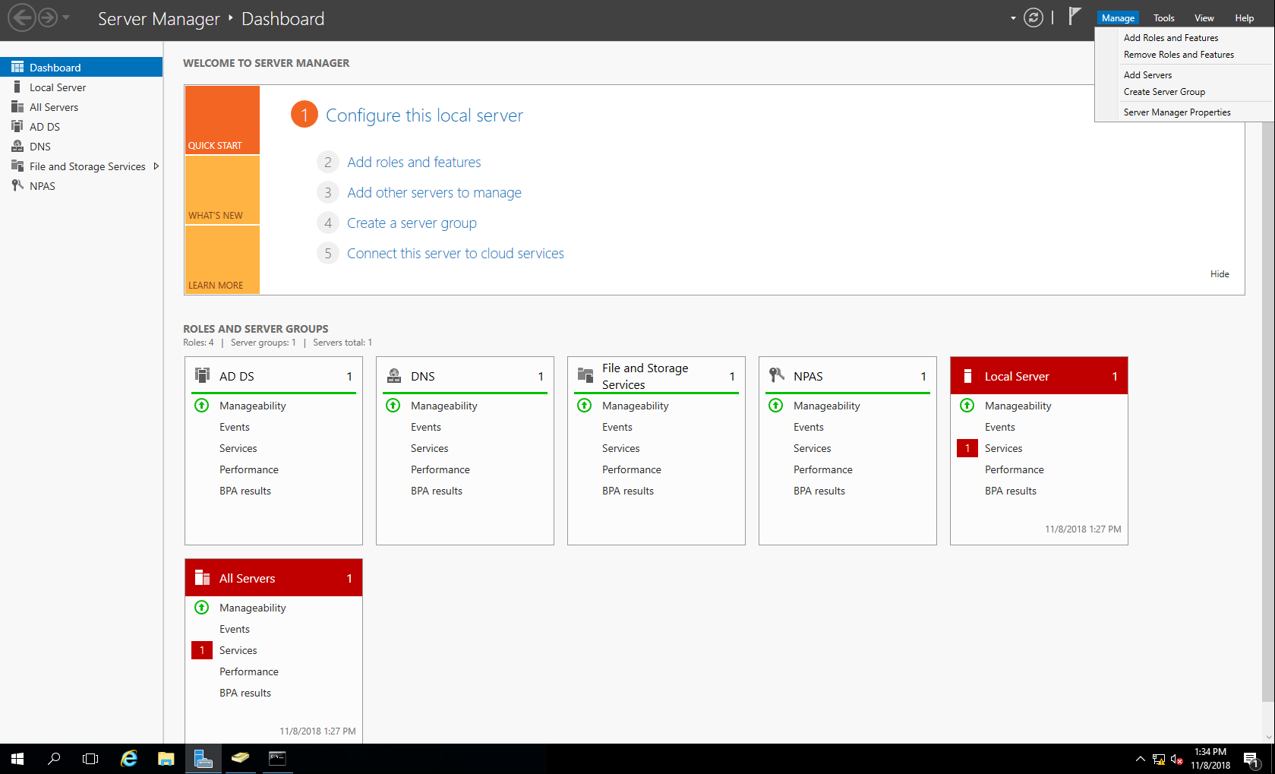

The next step is intuitive: select NPS server and Active Directory Domain to Download. After a successful download, you can find ADDS and NPS from your application list.

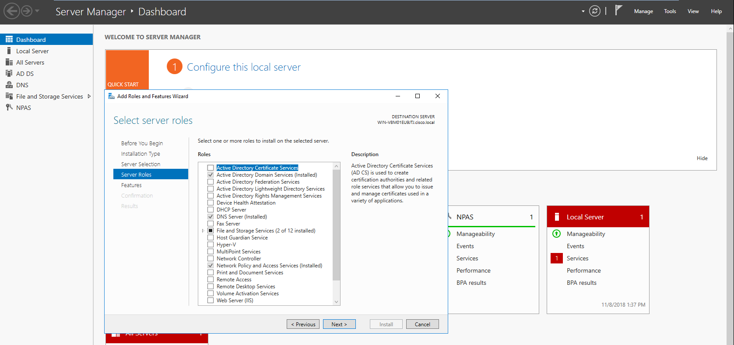

#### **Configuring Domain and Authentication in NPS**

First, I created and configured a TACACS+ domain that encompasses all devices under my server’s authentication process.

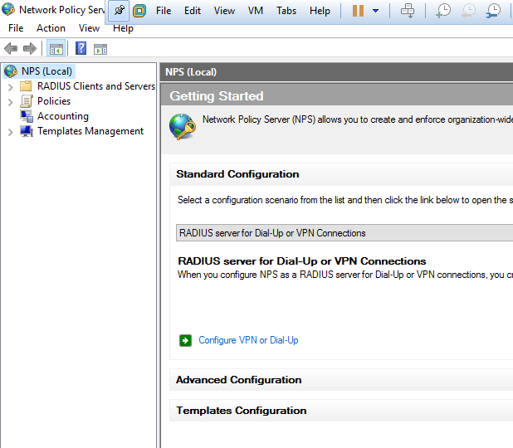

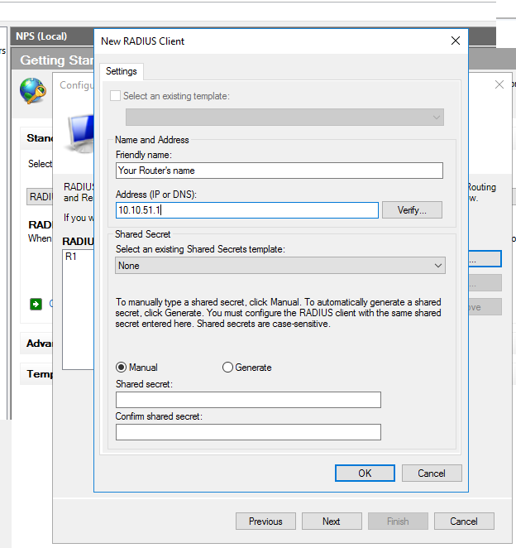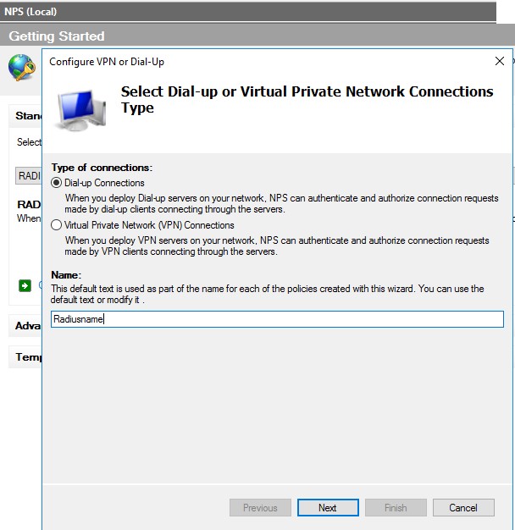

The name should be the name of your RADIUS platform.

Click “next” after name it. There are a lot of “next” in this GUI, just move forward and follow along with system instruction.

Define the Friendly Name with hostname of the router. Also type in the network that your network devices are belong to.

Share Secret should be the same as the shared key in router configuration. In this lab, I set it to a simple “123456”

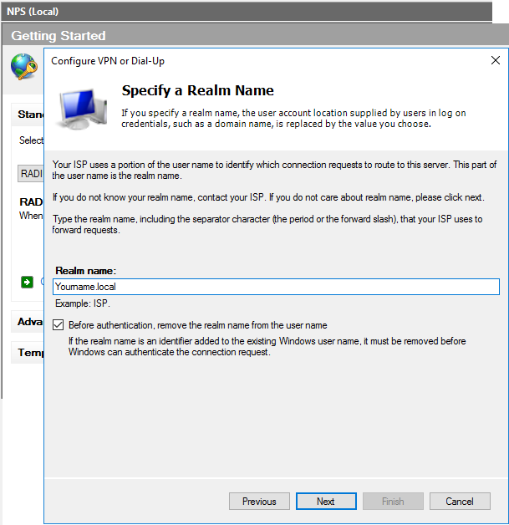

Realm name is important, because I need to use it in future steps. Since I am configuring a local network isolated from the Internet, I used “**local**” as my realm domain. You can choose a name you want before “.**local**”

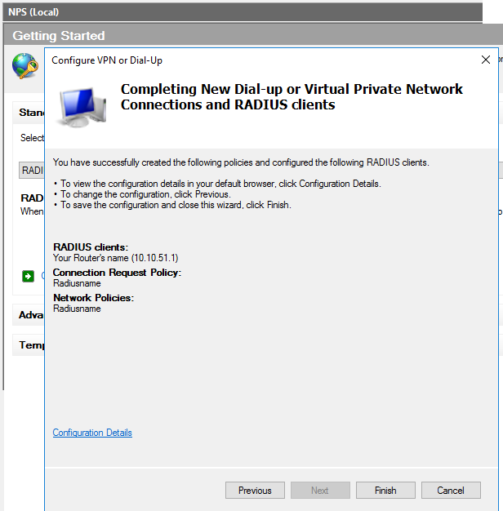

Confirmation step. After you click “Finish”, your RADIUS domain is created.

And here is the domain you just created. “cisco” is my working RADIUS domain that I configured for this project before.

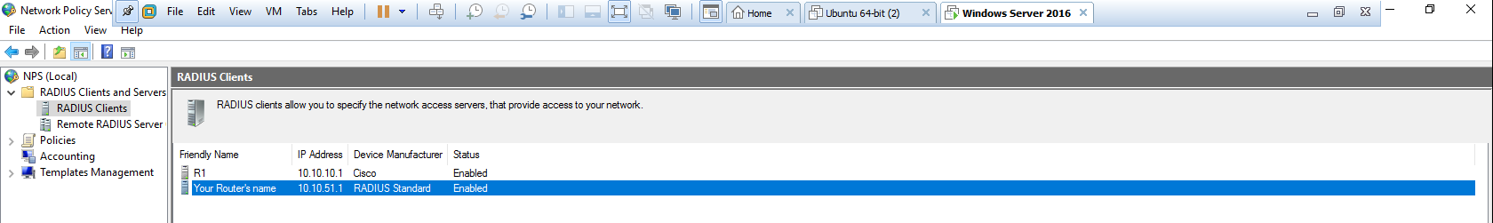

#### **Configuring Privilege and Administrative Network Policy**

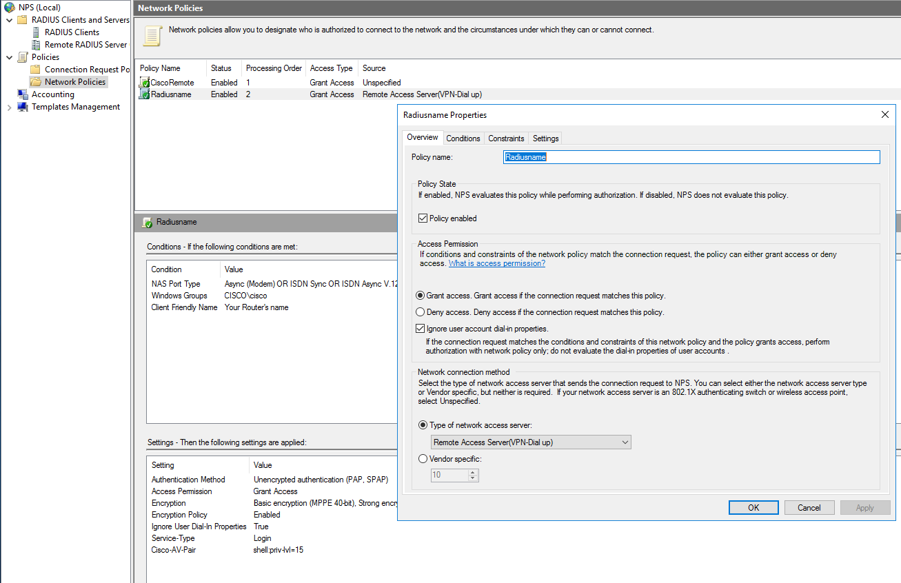

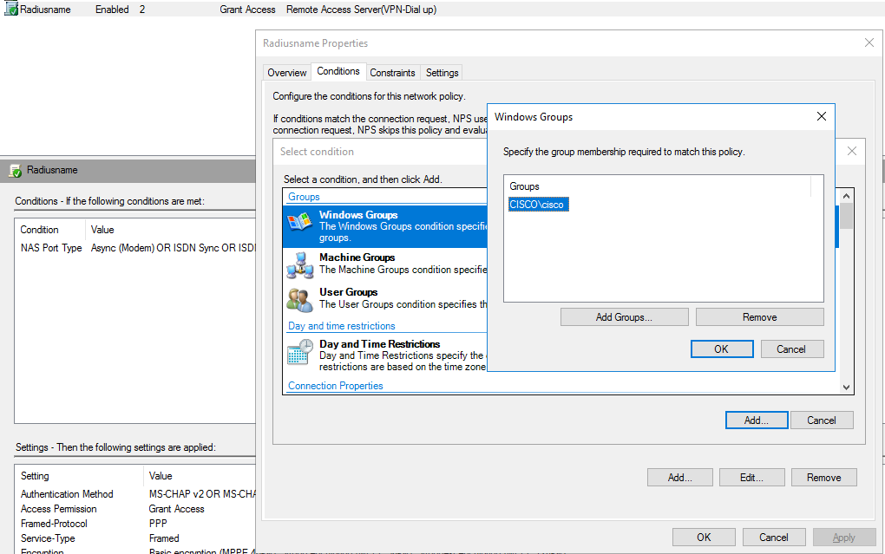

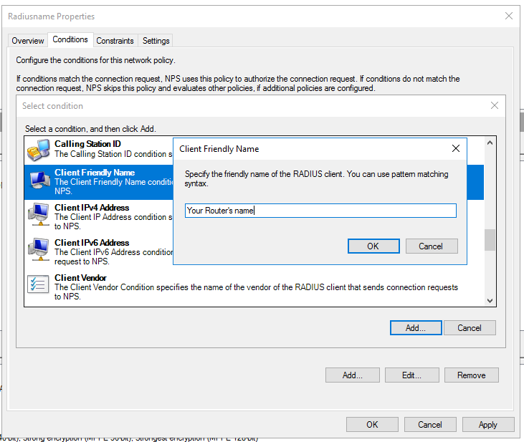

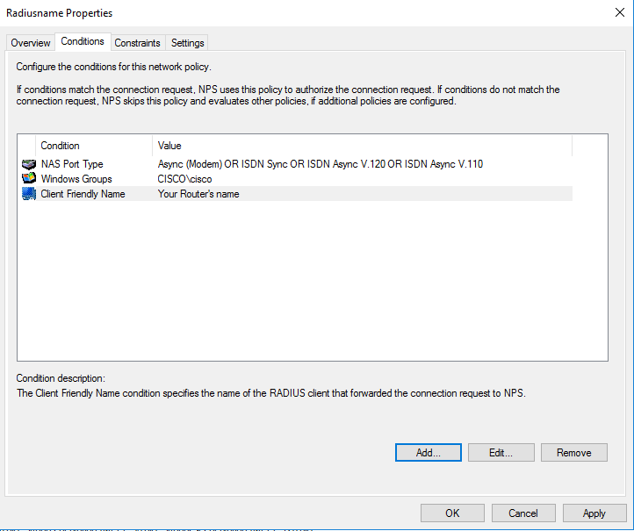

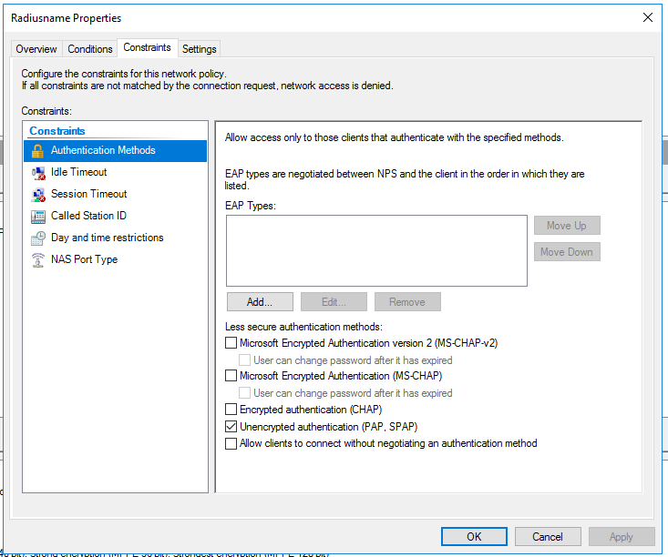

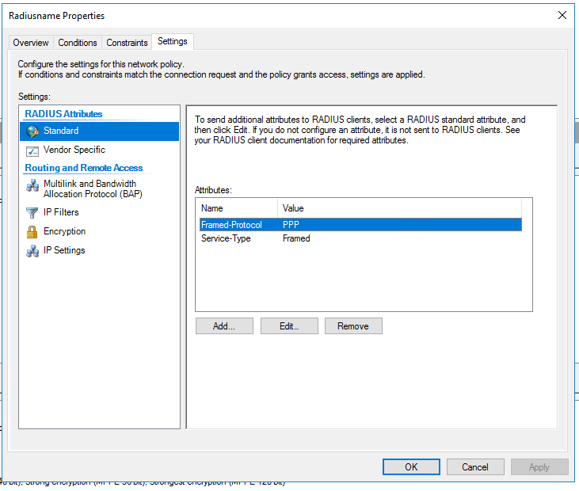

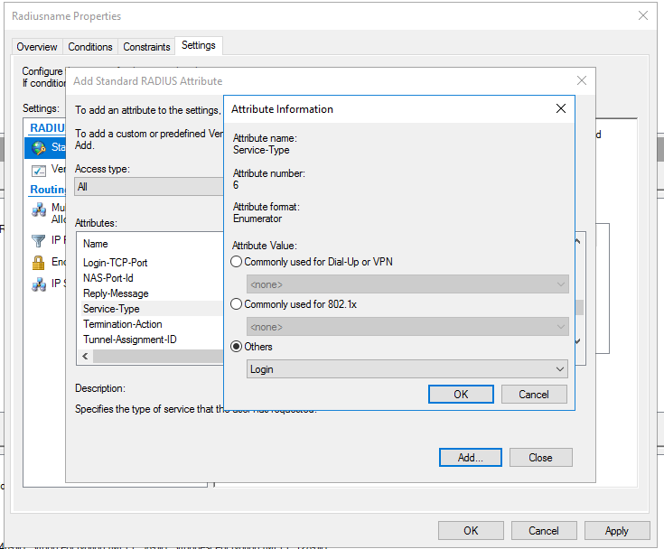

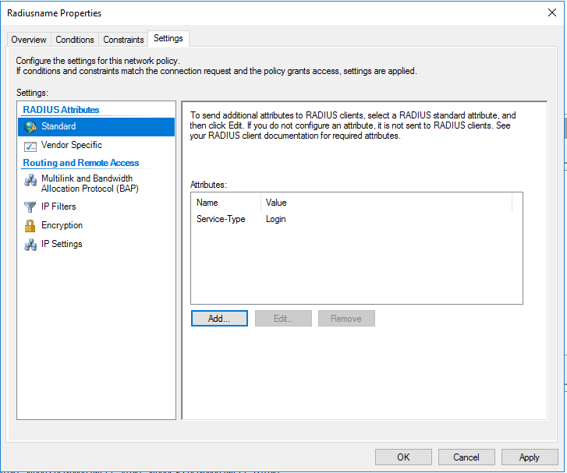

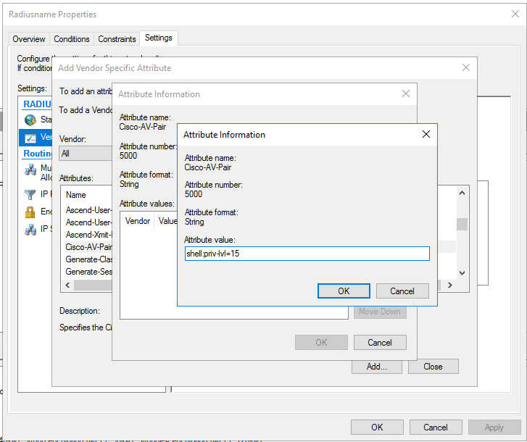

#### **Configuring Active Directory Domain Service (AD DS).**

## Problems encountered

**Linux TACACS+ Administrator directory:**

when I first configure the file for TACACS+ user directory, I thought that I only need to add a user into the directory with username and password. My username and password didn’t work, and I couldn’t log in to my router. However, I later found I must configure a group with defined privilege, and then assign users/admins under that group for TACACS+ to work. Now it makes sense to me because a privilege level must be defined in order for TACACS+ to operate.

**Log Out of Routers, Can’t Log In:**

When I configure first AAA accounting on routers, I didn’t set up my servers correctly, which leads to the failure in authentication. Since authentication failed, I couldn’t log in or do anything with my routers. At first, I had to power cycle my routers to erase my mistake, but that took a lot of time.

To solve this question, I need to configure a local user with:

**R1(config)**# username ***backup*** secret ***#####***

Now, I can log in to and configure my routers even though TACACS+ or RADIUS don’t work. Note that this local user will only be valid when the server is unavailable (for example, unplug the ethernet cable between server and routers).

**Not Sure About the Direction to Go:**

Before, I only configured routers in cisco CLI, or computer in GUI. I was clueless when two distinct interfaces intercepted, so I spent a lot of time following websites that don’t contribute to my project. After extensive research and discussions with my classmates, I learned that basic components of AAA authentication are an active directory, a shared key between routers and server and a defined network policy, any other things are security/ management preferences. After these three essential parts, I’ve built the skeleton of my AAA accounting platform.

**VMware connection issue. Two different modes**

The last problem is not really a problem in actual servers. Because my servers are virtual servers based on the ISO images in VMware, there are two ways that a virtual computer can connect to the physical network: either uses the same ip address as the physical PC, or a unique ip address different from the physical PC. In this lab, my virtual and actual computer each needs an ip address, so I need two ip address for one physical computer.

## Summary

Linux is much easier for the people who set up the server, because all essential parts of the AAA platform are concentrated in a script of codes. Though it’s not easy for a person new to Windows Server to find the right buttons to click, it has a lot of extra features and explicated options; and after all, it has a nice graphic user interface close to PCs that we use every day, which makes it more user friendly in some degree.